## Adding the Stop Bar and Turning Arrows

1. Using the **Rectangle** tool in the Shapes tab, create stop bars in the appropriate places. Ensure that your rectangle stroke color is white (it will be black by default).
2. Select a **Left turn** or **straight arrow** from the Furniture tab of the Signs Palette and place it on the plan somewhere. Ensure it is selected, then flip it using the flip horizontal button on the Flip toolbar. Drag it into one of the two required places.
3. Duplicate your modified arrow. Drag the duplicate onto the other side of the intersection as shown.
4. Now select a Left turn arrow and place it in both required places. Make sure you flip it accordingly.

* 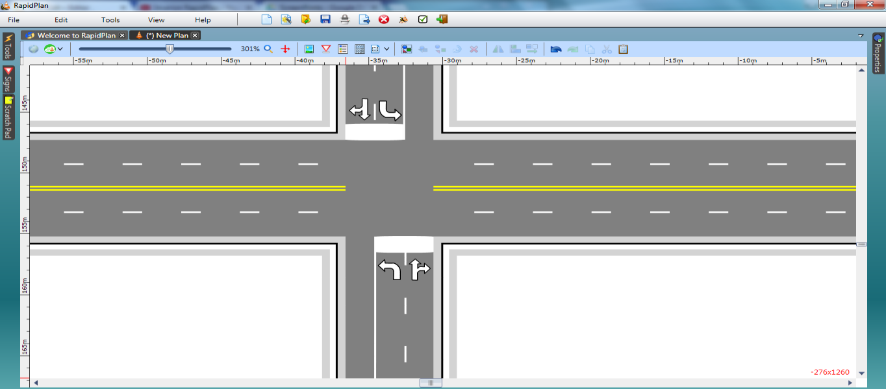
* Crossroads Intersection steps 8, 9, 10 and 11